About My Website

1. In my website I have addressed ethical/moral and legal issues. For the ethical and moral issues, I have avoided using any inappropriate content on the site (images, text etc). This way, the reputation of my site and myself will not be degraded.

For legal issues, I have mentioned at the bottom of each web page that the Background image was licensed under CC0 or in other words, it is in the public domain. When content is under this license, this means that anyone can use the content for any purpose without asking for permission.

As for my own site, I have licensed it under the CC BY-SA 4.0 license. With my own content under this licence, this means that:

* Anyone can copy and redistribute the content.
* Anyone can remix, transform and build upon the material, even commercially.

However:

* They must give credit and indicate if changes were made.
* If they redistribute or remix in any way, they must license their content under the same license.

1. I have ensured accuracy on my website. One way I have ensured this is by validating my code through an online tool run by the W3 consortium <https://validator.w3.org/>.

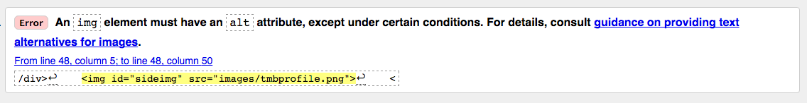When first using the tool, the following error occurred:

No Longer Damaged HD:Users:Anonymous:Pictures:Screen Shot 2017-04-02 at 8.47.23 PM.pngI rectified this error by adding an alt attribute to all of my images.

No Longer Damaged HD:Users:Anonymous:Pictures:Screen Shot 2017-04-02 at 3.45.47 PM.pngI then re-run the tool on the modified document and received the following message:

Another way I have ensured accuracy on my website is by checking the JavaScript console in my web browser for warnings or errors that could occur in the JavaScript code on the about page. Thankfully there were no errors.

1. During the development stage of my website, I have managed to economise the use of resources. One way I did this was to create pre-defined templates that I could duplicate, and later insert the relevant content into them. I think that this method has vastly decreased the time used to create the site.

Another way I have economised the use of resources is by using an external CSS file. An external CSS file is a file containing the CSS code for the entire site. Each of the HTML documents has a <link> tag, which imports the CSS code into the document. This way, I only need to write one CSS document for the whole site, rather than having to write multiple CSS snippets inside each of the pages of my site.